Bearspaw Bench Show
2019 Colouring Contest
Rules and Regulations

- NO PURCHASE NECESSARY TO ENTER OR TO WIN.

- Contest is open to all age categories. (Please see Bench Show catalogue at www.bearspawfair.com for age groupings).
- Contest begins Wednesday July 3rd 20th, 2019 and ends Saturday August 17th, 2019. All entries must be at the bench show office by Saturday August 17th at 10am. Entries can also be returned to the community location that supplied it by no later than Thursday August 15th, 2019. Take home a colouring sheet or print out the image and colour it in using any medium you'd like
- Limit one (1) entry per person. Each entry will get two chances to win a three foot teddy bear! Entries will be placed in the appropriate category for judging during our bench show.
- Entries will be judged for neatness, use of colour, and eye appeal. The decisions of the judges will be final and binding in all respects.
- Prizes will be awarded the afternoon of August 18th, 2019.

- Winner must be present to win the stuffed bear draw prize. First, second and third in each category will be furnished with a ribbon by the Bearspaw and District Community Fair Association.
Entries must be picked up by Sunday afternoon at 4pm. If you are unable to pick up your entry, items left behind may be moved to SURE Print Copy Cochrane.

Thank you for participating in our competition! www.bearspawfair.com
Name _________________________Age_____________________

Email for parent or guardian_______________________________

How did you find out about this contest?____________________

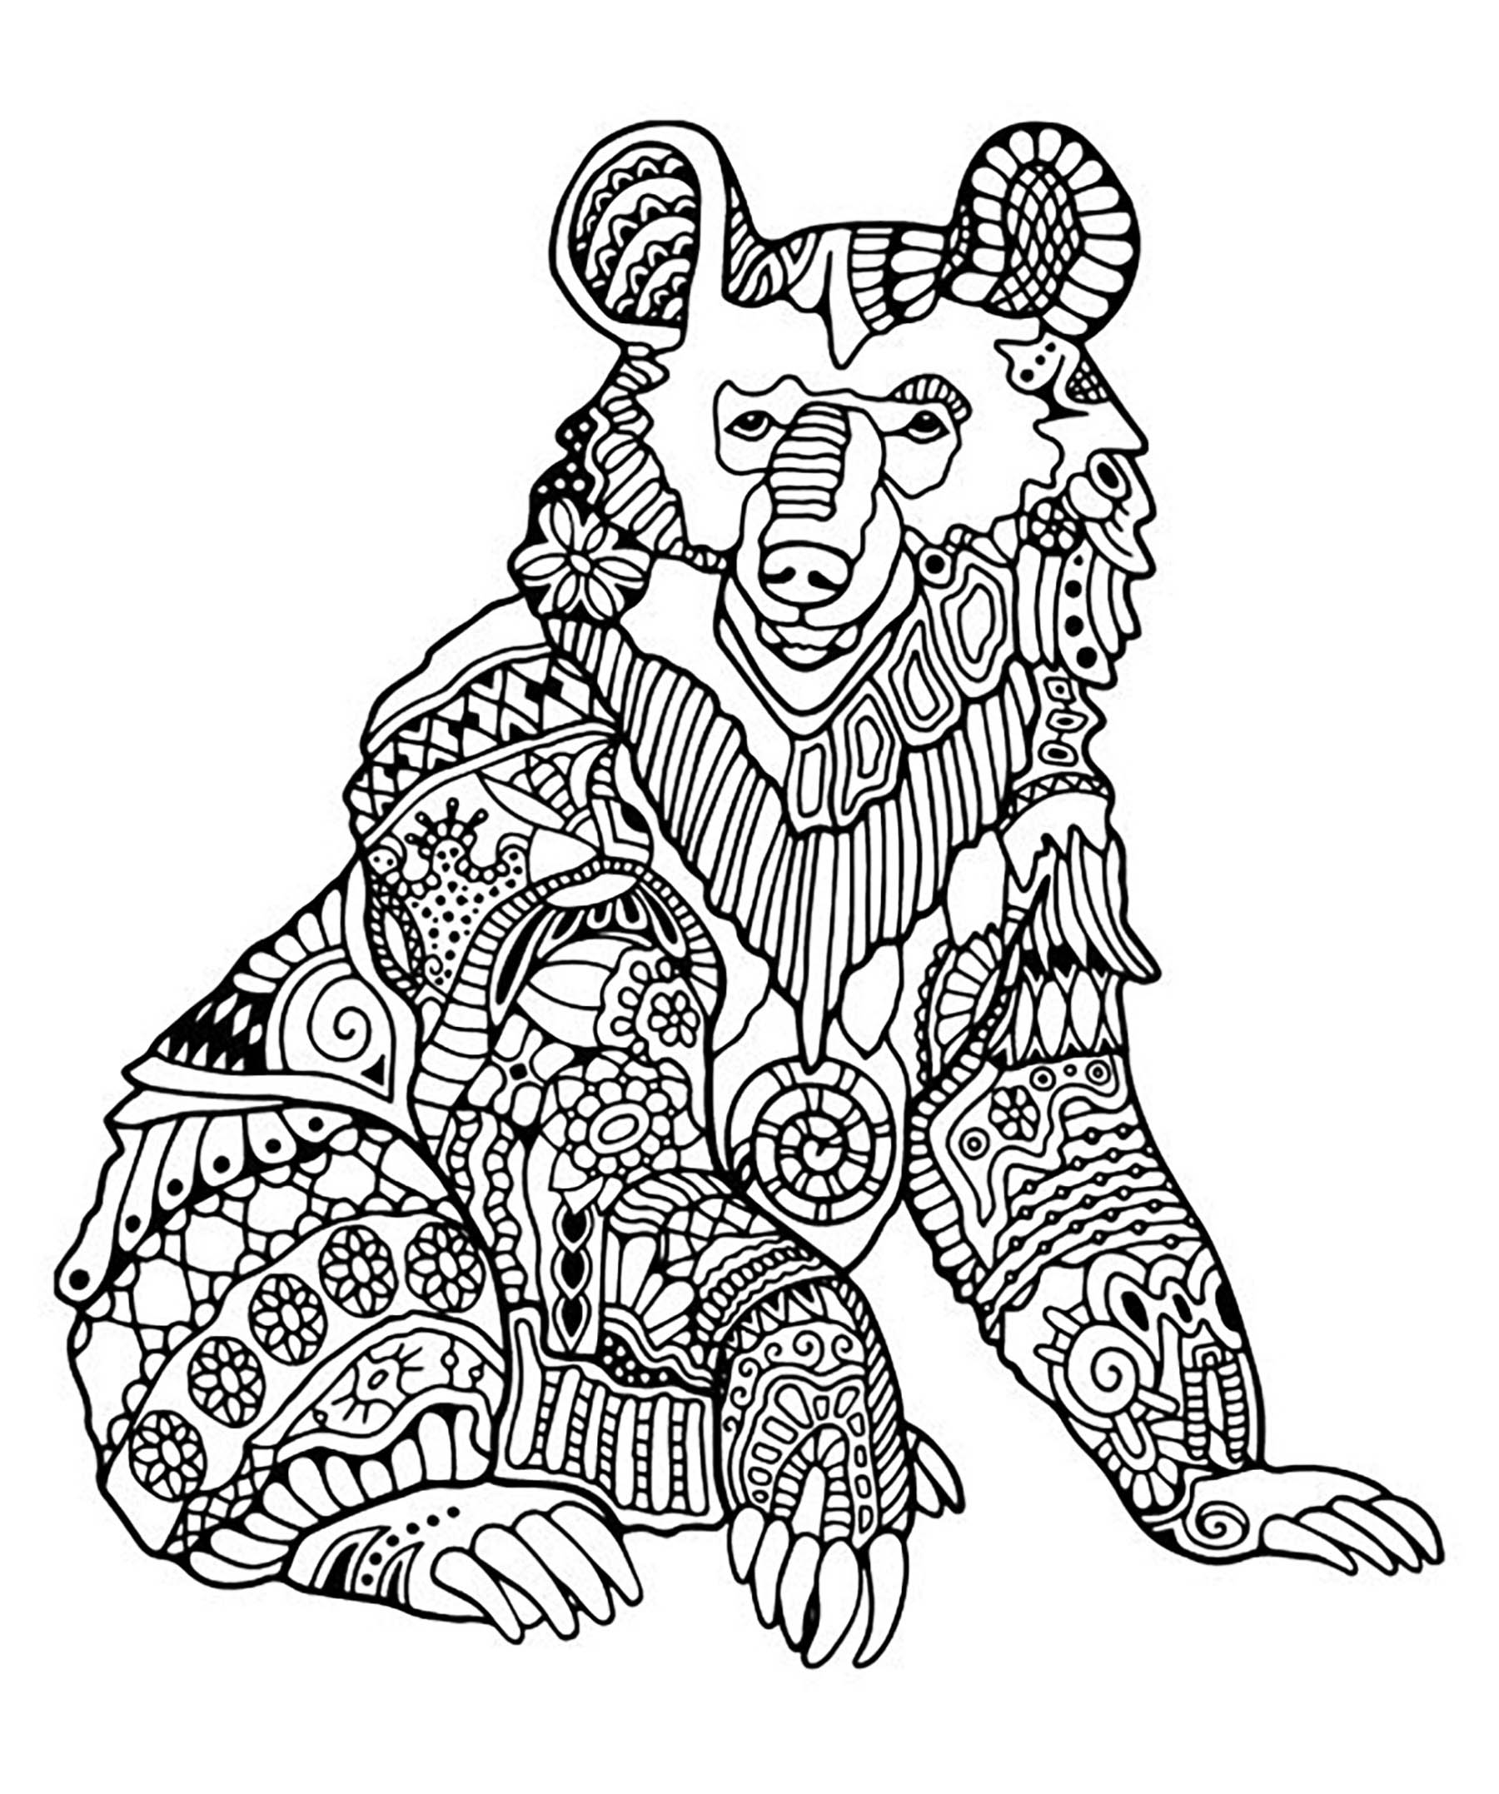

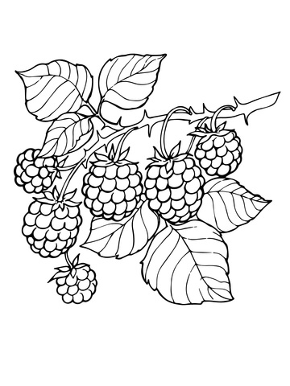
Thank you for participating in our competition! www.bearspawfair.com
Name _________________________Age_____________________

Email for parent or guardian_______________________________

How did you find out about this contest?____________________

